Predicting ESRB Rating by Random Forest Classification

The Entertainment Software Rating Board (ESRB) is a self-regulatory organization that assigns age and content ratings to consumer video games in the United States and Canada. The board assigns ratings to games based on their content, using judgment similar to the motion picture rating systems used in many countries, using a combination of six age-based levels intended to aid consumers in determining a game's content and suitability, along with a system of "content descriptors" which detail specific types of content present in a particular game:
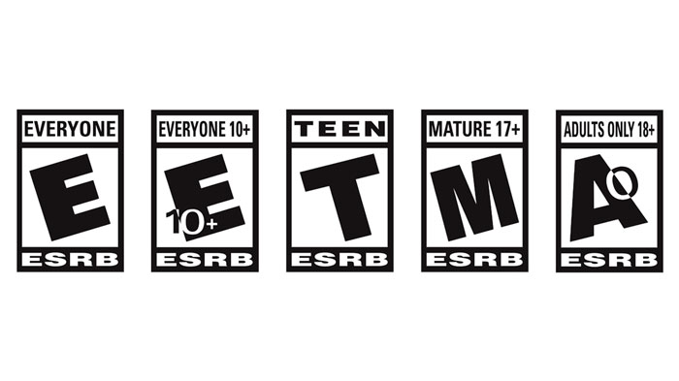
Given a dataset containing a boolean representation of the presence of these content descriptors, we aim to train a classification algorithm to predict the ESRB rating a sample video game would receive in a typical review process, without the need to assess its content manually. Typically, this is done by humans who recieve instruction in the classification process using a traditional rubric method of grading. An accurate classification algorithm could reduce the time it takes for a developer or publisher to receive a preliminary rating, and allow them to make informed plans for release faster.

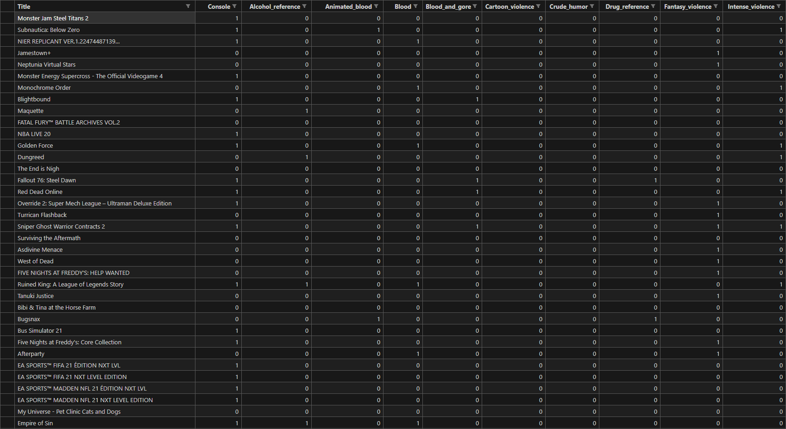
*sample of dataset

The dataset we are using to train and test our algorithm is a collection of released and reviewed games with fields for the presence of ESRB content descriptors used in the current ESRB process. The non-testing data contains 1895 entries, with 36 features for each game inclusive of name of the game and console release status:
title console
alcohol_reference animated_blood
blood blood_and_gore
cartoon_violence crude_humor
drug_reference fantasy_violence
intense_violence language
lyrics mature_humor
mild_blood mild_cartoon_violence
mild_fantasy_violence mild_language
mild_lyrics mild_suggestive_themes
mild_violence no_descriptors
nudity partial_nudity
sexual_content sexual_themes
simulated_gambling strong_language
strong_sexual_content suggestive_themes
use_of_alcohol use_of_drugs_and_alcohol
violence esrb_rating

We believe that this feature set will give us a high degree of classification accuracy, as we have access to the descriptor values used in many previous actual reviews, and many binary features where the classification threshold is clear and cases discrete. We have a test dataset that is disjoint with the training dataset with several hundred entries.

The program should then be able to classify any game given a random set of features. After the trained algorithm classifies a hypothetical sample game, we suggest similar titles which have already undergone the current ESRB rating procedure to help a human reviewer check their work by comparing with older games to check for consistency between ratings. This added context has the potential to smooth friction between the targeted rating and the reviewer and reduce the frequency of contested ratings.

Our team is:

Ali Elayni
Richard Recar
Armand Soto

